ADT Report Names:
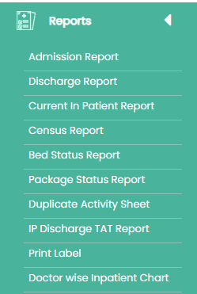

1. admission Reports
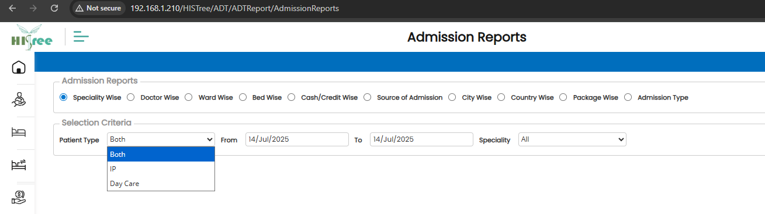
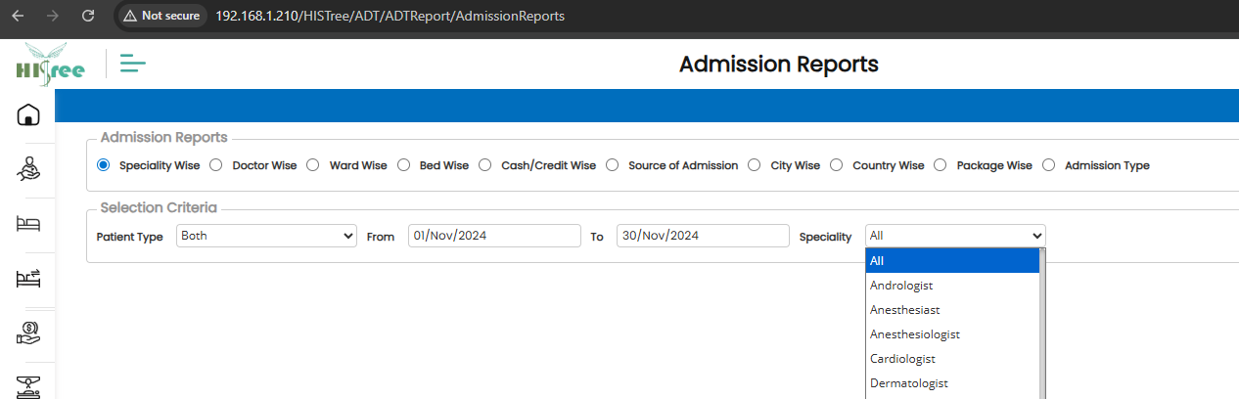

2. DischargeReports
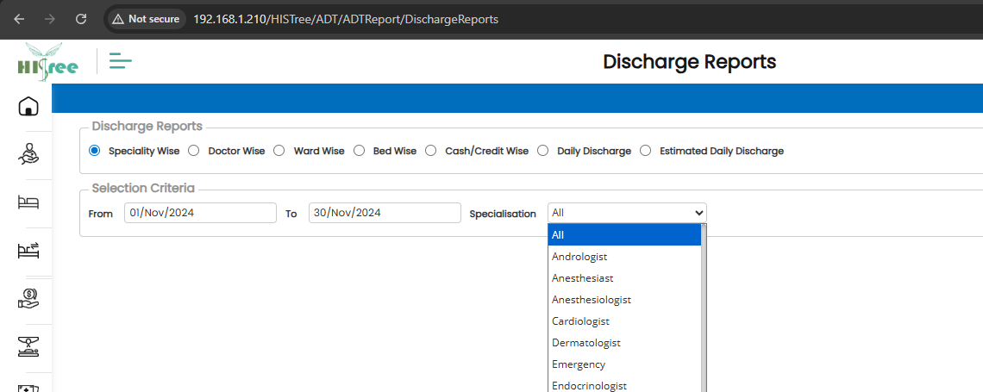

3. Current In Patient Reports
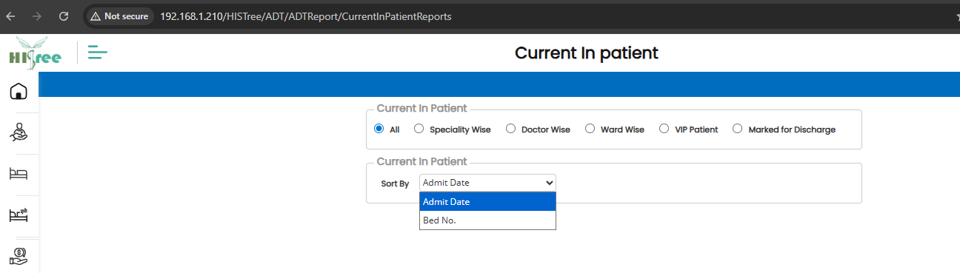

4. Census Reports
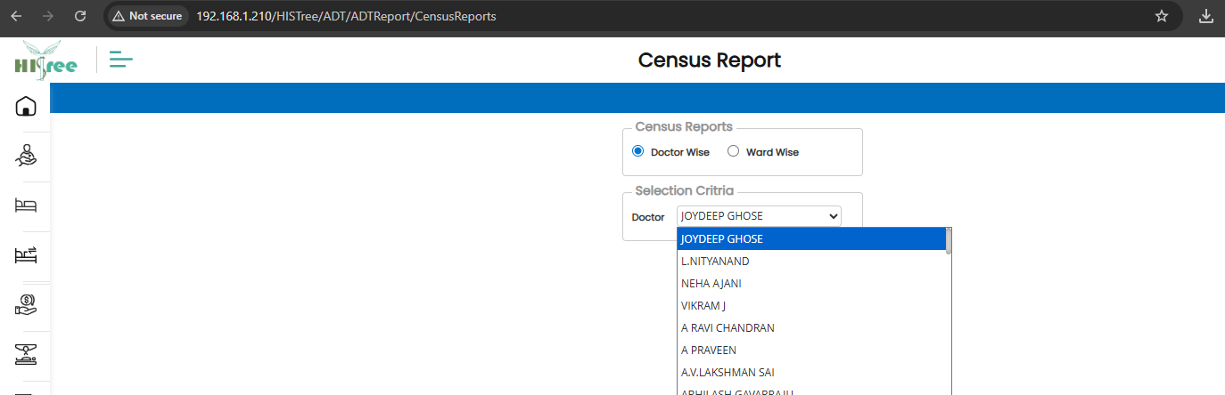

5. BedStatusReports
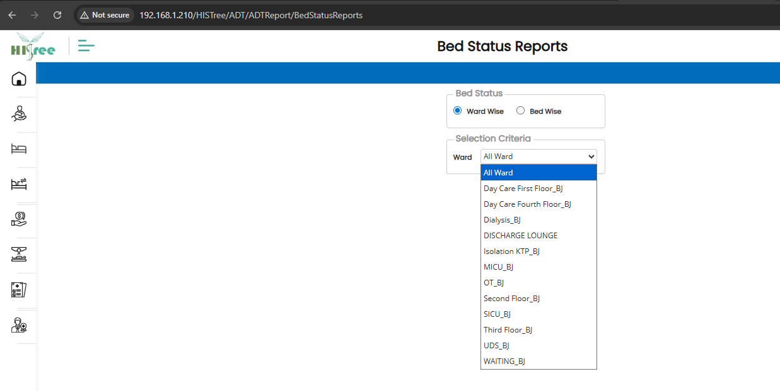

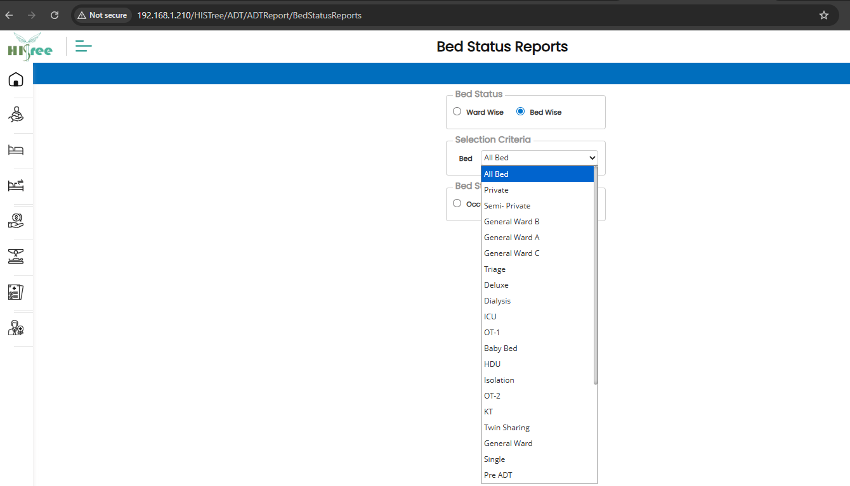

6. Package Status Reports
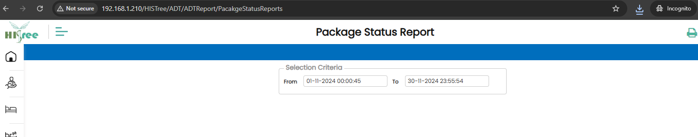

7. Duplicate Activity Sheet ADT
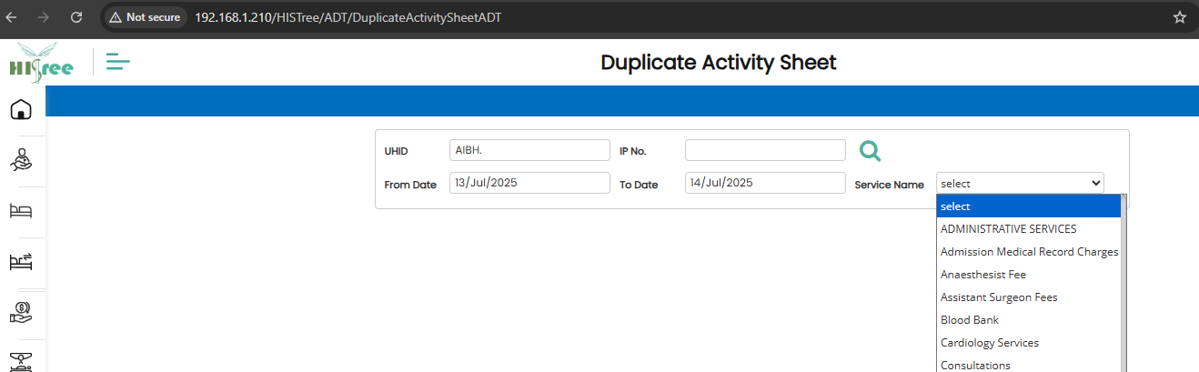

8. IP Discharge TAT Report ADT
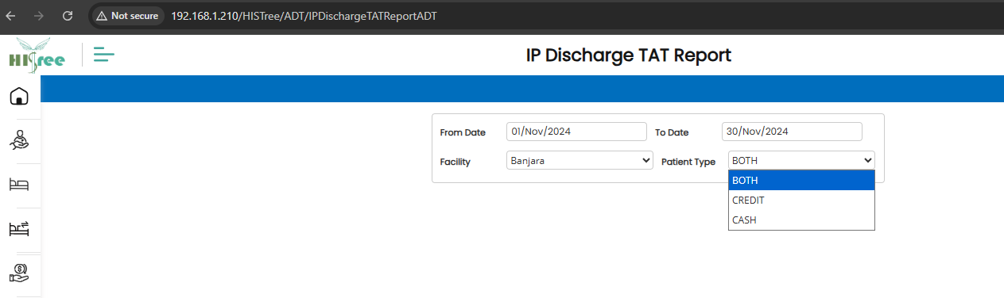
9. Print Label ADT
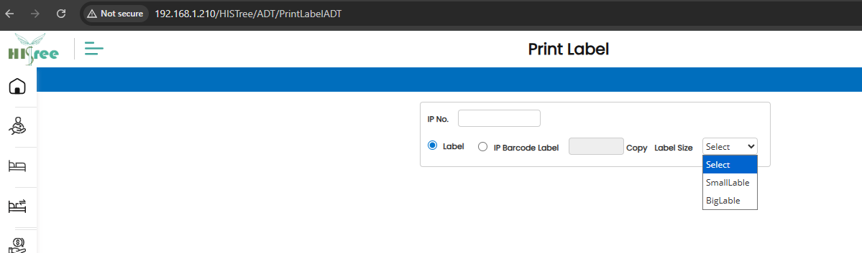

10. Doctor wise Inpatient Chart ADT
